Lab 09a - Implement Web Apps

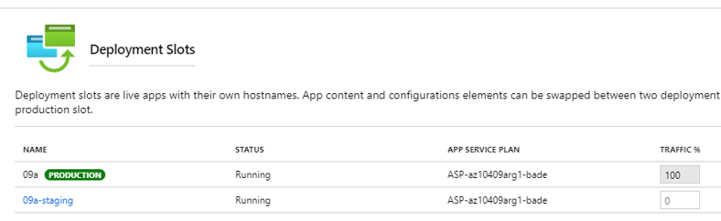

On the staging slot blade, when we click the **URL** link it displays the default web page in a new browser tab.

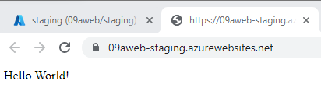

Then I swap the staging slot with the production slot and it shows again the same text:

